Jennifer Furr
July 10, 2016
Child Prodigies Who Create Art

https://www.pinterest.com/jenniferfurr/youth-created-art-for-uf-are6933/

http://jenniferfurr.weebly.com/are6933-child-art-study.html

Confidence. It is the one thing that all the child “prodigy” artists I discovered have in common. Even though there is a wide variety in the mediums these artists use, their confidence and creativity is the common factor that is seen so clearly through their interviews and demeanor.
Aelita Andre, age 9, show intensity and focus as she dribbles paint on the canvas and sticks other items in the paint.
Aelita Andre, age 9, working on a painting.
She seems determined and works with the same seriousness that adult artists do. Andre, in fact, was the inspiration for the art I created for this study. According to Shearer (2004), the definition of intelligence is the ability to solve problems. Gifted students are known for their problem-solving abilities, so it is no big surprise that gifted child painters are able to quickly solve problems in their artwork and master skills more quickly than other students that are the same age.
Most people that have heard anything about gifted child artists will think of Akiane Kramarik’s name when they hear the phrase “child prodigy artist”. Kramarik started painting at the age of 4, and the complexity and themes of her paintings only deepened over the years. Many others will think of Kramarik (now 22) when they think of her beautiful and otherworldly religious paintings. Kramarik has appeared on Oprah, Good Morning America, and many other television shows. Golomb (1999) said that an artist’s goal “is to create a pictorial world imbued with meaning and feelings, to interpret some aspect of reality rather than to construct a faithful replica of it” (p.47). Kramarik has, indeed, created her own world through her paintings of heaven and other religious themes, which certainly have no way of being faithfully replicated since no one currently alive has seen these things.
“Supreme Sanctuary” by Akiane Kramarik, one of her paintings of heaven.
One, or perhaps I should say two, of my favorite child prodigy artists in this study were Victoria and Zoe Yin, ages 14 and 11. Victoria and Zoe both excel at using bright, bold colors, and weaving a story from classical artworks they borrow, and create new geometrical shapes from them in their paintings. Their technique of borrowing and “upcycling” reminds me of how Wolf (1988) said that “no artist could survive without borrowing techniques and images that come either from the public domain or from other artists” (p.148).
In the video interview with Victoria Yin I viewed on my Pinterest board, she shows classical hallmarks of the gifted child, such as an extensive vocabulary, the ability to explain her own symbolic methods, and the desire to spend more time with people older than her than with people her own age. Symbolism in art is very important, according to Eisner (1978), who said that “symbol-making, a process requiring abstraction and transformation of one thing into another, is a natural human capacity upon which thought and consciousness itself depend” (p.7). Victoria showed a maturity beyond her years, another gifted trademark, which shows up in the themes of her art, with subject matter ranging from Artificial Intelligence and our future with robotics, backward in time to surrealistic paintings involving sculptures from Leonardo and Michelangelo.
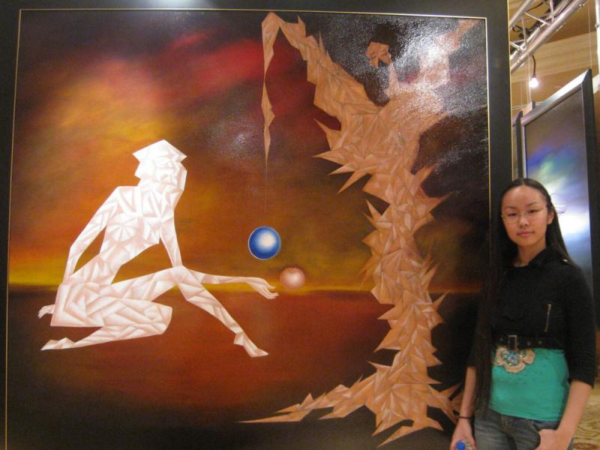
Victoria Yin with her “Dawn of a New Civilization, the Seed of Wisdom”.
Autumn de Forest was another child artist that takes classical works and puts her own spin and colors into them. De Forest has a vibrant, bubbly personality, which fully translates into her artwork. She painted “American Gothic” by Grant Wood her style, with bright colors and a big crayon in the middle.
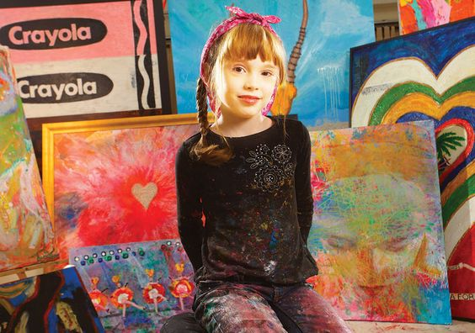
Autumn de Forest and her colorful paintings.
It was interesting to see that at 12 years old, de Forest was utilizing a similar technique to Yin, who was 14 at the time. Seeing this would make me wonder about what Feldman (1987) said when he stated that “the major lesson of the study of universal developmental changes is that children at different age levels tend to have quite differently organized minds and to go about their business in quite different ways; they are preoccupied with different issues and make sense of the world in dramatically different ways” (p. 249). I had to wonder if these two girls were close enough in age that they were at the same developmental stage, or if giftedness puts them in a completely different ballpark all together.
Roberto Cantilla Salas, 8 years old at the time of his interview, has been drawing since he was 3 years old, and slowly graduated into the world of painting.
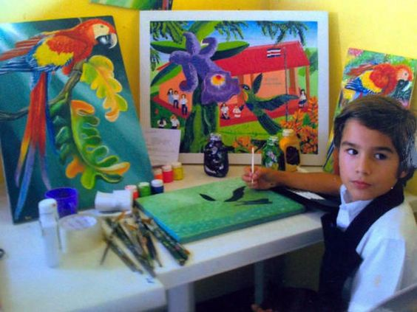
Roberto Cantilla Salas, with his paintings of local life.
He likes to depict local Costa Rican flora and fauna in his colorful paintings. Seeing his paintings made me think of the Louis (2005) article, when she said that “a medium such as paint provides children with unique opportunity to create continuity between personal and cultural experience” (p.349). Salas seems to be doing a fantastic job of translating his personal thoughts about his cultural surroundings onto the canvas.
Hamzah Marbella, a 12-year old artist from the Philippines, uses a color palette that is similar to Salas’, but his subject matter is much different, mostly abstract, surreal, or fantasy paintings. His tools have evolved over the years from pencil to pastel, and sketchbook to plywood. Once again, the Louis (2005) article came to mind, when she said that “even if children stumble upon the representational possibilities of a medium accidentally, the way they make use of that accident is mindful, and based on what is happening in the moment” (p.349). The stages of Marbella’s development with different art tools made me think of Shearer’s (2004) explanation of Feldman’s six stages of the developmental continuum, with the discipline-based stages of novice, apprentice, journeyman, craftsman, expert, and master.
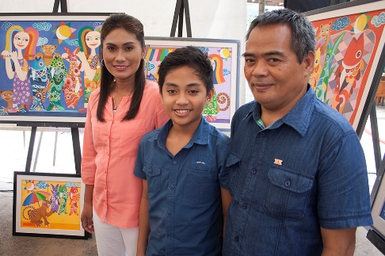
Hamzah Marbella with his parents and his art.
But do all gifted child artists, “prodigies”, go through the different developmental stages like all other children are thought to? Golomb (1999) said that “there is evidence that even the artistic child prodigy does not skip stages, but masters them more fully and at a much more rapid pace than his agemates” (p.39). Whether it is a mastery of stages, an intuitive talent, or hard work bred from higher intelligence, or a combination of all these factors, child art made by these child prodigies, and especially hearing their explanations about their own art, is in my opinion, quite fascinating.

References:
Eisner, E. (1978). What do children learn when they paint? Art Education, 31(3), 6-10.
Feldman, D. H. (1987). Developmental psychology and art education: Two fields at the crossroads. Journal of Aesthetic Education, 21(2), 243-259.
Golomb, C. (2003). Art and the young: The many faces of representation. Visual Arts Research, 29, 120-143.
Louis, L. L. (2005). What children have in mind: A study of early representational development in paint. Studies in Art Education, 46(4), 339-355.
Shearer, B. (2004). Multiple Intelligences Theory after 20 years. Teachers College Record, 106(1), 2-16.
Wolf, D. (1988). Artistic learning: What and where is it? Journal of Aesthetic Education, 22(1), 143-155.

