Artistic Development
Self-Study
http://jenniferfurr.weebly.com/artistic-development---self-study.html
http://issuu.com/jenniferfurr/docs/furr_issuu_paper/1

By
Jennifer Furr

8/6/16

University of Florida
ARE 6933

About 16 years ago, in the Spring of 2000, for my senior art display at Troy University, I wrote an artist’s statement I titled “Abstract Dreams”. All the pieces in my display were fairly abstract, definitely expressionistic, highly personal (as pertaining to things occurring in my life at the time and in the past) and all done in oil pastels. My art has changed immeasurably in the past 16 years, but my influences have not so much.
My artist heroes at that point were Vincent van Gogh, Paul Klee, Henri Matisse, Edvard Munch, and Salvador Dali. These five still remain some of my favorite artists, for their bold and beautiful use of color and subject matter, but I have added a few more to my list. Now that I am older and have lived quite a bit, I understand how hard it can be and definitely used to be, for women to be accepted and appreciated in the art world. Georgia O’Keefe and Frida Kahlo are my top two favorite women artists for their beautiful imagery, and also for their beautiful, vivacious, strong-willed spirits. I have also come to appreciate the intricate psychologically influenced art of M.C. Escher, as well as the surrealistic stylings of Rene Magritte. Pablo Picasso and Henri Rousseau have also become my favorites, for their vibrant colors, and shapes. Picasso with his cubism and Rousseau with his “naïve” style. In general, I am drawn to beautiful, bright colors and personalities. They become influences and incorporations in my art and psyche as well, I’m sure. Sometimes, I think, as artists, we steal or “borrow” on a very subconscious level, especially after years of repeated exposure to the same artists and paintings.
I did not really begin my own art journey until I was in college. I had exposure to art from a young age, though. My mother loved to draw and watercolor paint at home. Her style was very realistic, and I could never quite conquer it, or even come near to it when I was a child. She did, however, let me use a children’s guide to drawing, which showed how to use basic shapes to draw animals, and I used those techniques for years in my childhood. One year in high school, I was finally able to sign up for an art class, 10th grade, I believe, but then had to drop it about a week later, because the Spanish class I needed to take was offered at the same time. A few years later when I started junior college full-time, I took my first art history class, and I felt like I had found my place in the world. I had taken a few black and white photography classes through my dual enrollment classes in college during high school, but they didn’t compare with learning about the great art the world had to offer.
At the junior college I attended, there were two main instructors at the time for art classes. One taught photography, and the other taught art history, drawing, painting, and pottery. So, most of my “early” art education was from the same person, Larry Manning. I think I was inspired to continue learning and absorbing everything I could about art because Mr. Manning was so interesting and truly had this love and passion for art that showed in his lectures and his art work. He was the teacher who was always painting on a huge canvas or throwing a pot on the wheel in between classes or after hours. He never took himself too seriously, and encouraged everyone. That was a huge inspiration for me at the time.
When I transferred to Troy, my experience with art was not quite the same. Troy is a pretty large university, as far as student population goes, so the art faculty was pretty diverse. I had one instructor that I absolutely loved, but only had her for one class, and I can’t even remember her name now. I remember she was kind, and a good listener. I think her name was Mrs. Olsen, but I’m not sure. I can’t say that I really connected with any of the other art faculty while I was there. The other instructors I had were male, older, and pretty much seemed to be wrapped up in their own projects. I was also majoring in journalism at the time, and I really had no idea what I was going to do with my life “when I grew up”.
So, fast forward to a few years later, and I was working as an elementary teacher in the public school system. I didn’t have much time to do art for enjoyment at first, other than beadwork. After teaching for a few years, I started trying to incorporate art work into my curriculum. Then I had my first child, my daughter, back in 2008, and got back into doing art a little more when she was a few years old and liked to make things along with me. We painted tons of birdhouses one summer, and miniature Mardi Gras masks, and then branched out into other things. We painted ceramic figures, wooden toys, canvases, an old freezer, anything that wasn’t nailed down.
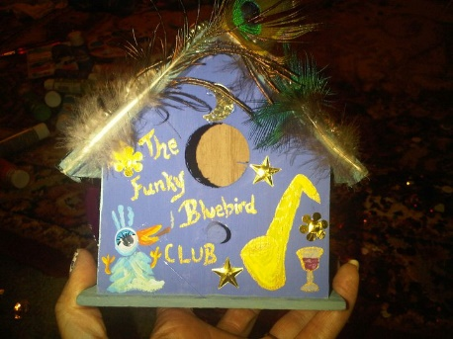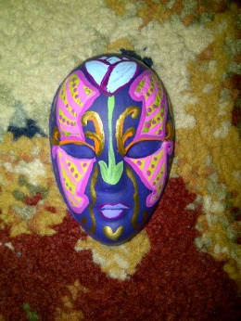
One of our first birdhouses, c.2011. Miniature Mardi Gras mask, 2011
My daughter’s biological father and I separated in 2011, and our divorce was finalized in 2012. Art was the only thing besides her that kept me going. I didn’t know the term “art therapy” at that time, but that’s exactly what I was doing for myself. I was drawing, painting, taking tons of photos, anything to numb the pain and temporarily forget it. When I started going to real therapy, the psychologist praised my artwork, and encouraged me to keep at it. I did, and kept my daughter involved in projects with me as well. I began to think that I would really love to be teaching art, if only a position would come open. And then finally one did.
I couldn’t believe how happy I was to finally be teaching art, and still am. Yes, there are days that some classes are challenging, but there are also times when it doesn’t feel like work at all. I didn’t really know what I was doing when I was hired in the Fall of 2014 to teach art. I had been interested in this program at UF for at least a year prior, and then decided it was time to enroll, so maybe I would know what I was doing, teaching art to a whole school full of young children. I didn’t even think about it until tonight when I was looking back over all the projects and papers that I have posted on my Weebly website for UF, just how much I have learned in the past year and a half.
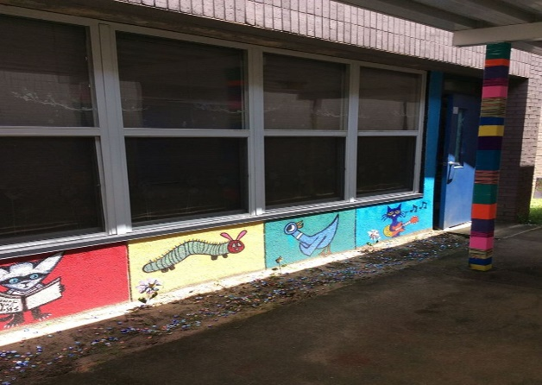
I learned that children need inspiration, too.
Through the Master’s program for Art Education at UF, I have learned about contemporary art practices, which I really knew nothing about before, the history of art education, theories of development in art education, curriculum in art education, museum practices in art education, globalization in art education, child art, as well as studio classes like the digital image, digital video, and mapmaking in art. I have learned different things from each class which I have applied in my teaching. For example, during the Spring, I taught my Gifted class how to make videos and edit them. I could have never done that prior to taking the digital video class. At some point last year, I started setting up “stations” or art “centers” in my classroom for early finishers. I was inspired to do this by reading about Froebel and his gifts during the history of Art education class. Froebel wanted to make materials that would suit the social and cognitive needs of children (Sienkiewicz, 1985). He thought that art was the most sublime form of play. I thoroughly agree with Froebel, and have tried to give my students the time and freedom to play with art tools and materials during my class time.
Henry Turner Bailey was another influential person I learned about in the history of art education that has influenced my teaching practices. He believed in holiday art and the use of seasonal activities to teach the elements and principles of art with (Stankiewicz, 2001). I tried this method several times last year, especially with Dia de Los Muertos art, and the kids absolutely loved it. Of course, this also ties into what I learned in Dr. Delacruz’s Globalization in Art education class, and integrating multiculturalism into the curriculum. In that same class, I researched Kawaii art, which I knew my students loved, and found out more to teach them about it, like that the word first originated over 100 years ago, in 1914 (Kincaid, 2014). I can also teach them about the woodblock printing styles that first influenced it, with artists like Hokusai. That goes along with connective aesthetics, which I learned about in this class, and how people and art are connected. And I think that is one of the most important things to teach children, that we are all connected. I don’t think they should be viewed in terms of a developmental stage, like Piaget theorized, but rather as a whole child, an individual, a budding artist.
Resources:
Kincaid, C. (2014, September/October). What is Kawaii? Retrieved April 16, 2016, from http://www.japanpowered.com/japan-culture/what-is-kawaii
Sienkiewicz, Carol. (1985). The Froebelian kindergarten as an art academy. The History of Art Education: Proceedings from the Penn State Conference; NAEA Publishing
Stankiewicz, M.A. (2001). Meaning and purpose of holiday art, and we aim at order and hope for beauty. In M.A. Stankiewicz Roots of Art Education practice, (pp.68-103). Worcester, MA: Davis Publications.

